Week 4 practical.

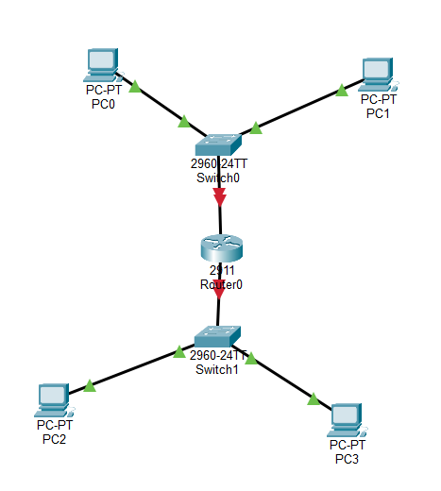

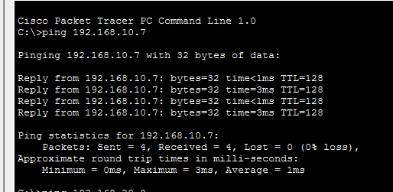

Pinging: From PC0 to PC1
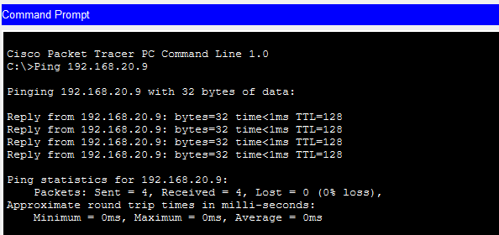

Pinging: from PC2 192.168.20.8 to PC3 192.168.20.9

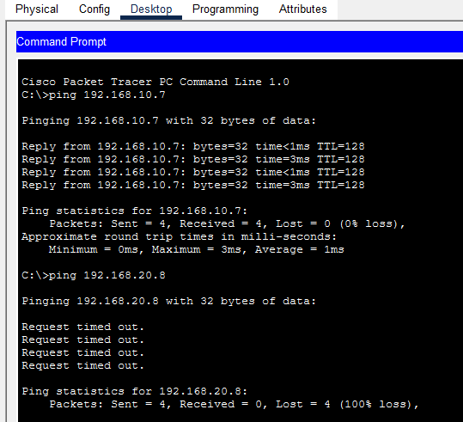

Ping from PC0 192.168.10.6 to PC2 192.168.20.8 is unreachable no connectivity from the gateway
